**How to access TEAMS!**

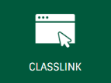 **First go to www.fultonschools.org**

**Scroll down a little to the green bar and find ClassLink – Last Icon**

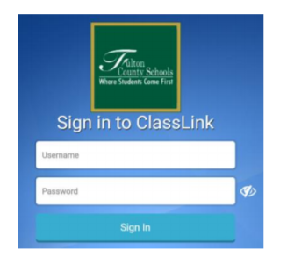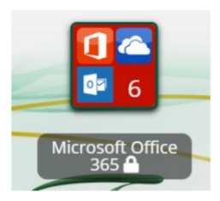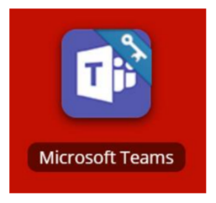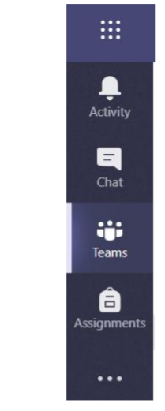

**STEP 1**

Log into ClassLink using your student id. The password is your birthdate.

**STEP 2**

Choose the Microsoft Office 365 App.

**STEP 3**

Choose the Microsoft Teams App.

**STEP 4**

Use the navigation bar on the side to choose the class Team you need to join, to chat with your teacher, and to view assignments.